**Project Details**

|  |  |
| --- | --- |
| Project number | *9* |
| Project title | *Mega store corporation* |
| Corresponding TA\LA | *LA\Alia Magdy* |
| Deliverable | *4* |

**Team Details**

|  |  |  |
| --- | --- | --- |
| **Student ID** | **Student name** | **Lab Group** |
| 20201203 | Nourhan Amr Abd El-Wahab | S6 |
| 20201189 | Nada Emad Mohammed | S8 |
| 20201041 | Aya Hasanin sayed | S6 |
| 20201191 | Nada Mohammed Ahmed | S1 |
| 20200606 | Nour Yasser Mahmoud | S6 |
| 20201182 | Mai Tarek Ahmed | S8 |
| 20200522 | Mariam Tarek Galal | S5 |

**CRC for Return Product**

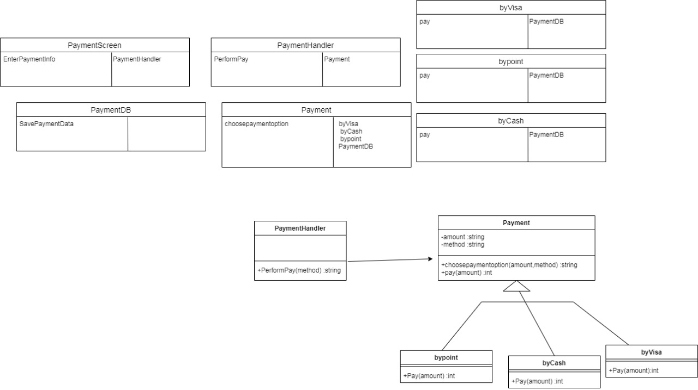**CRC for Payment.**

**Communication Diagram for Payment**

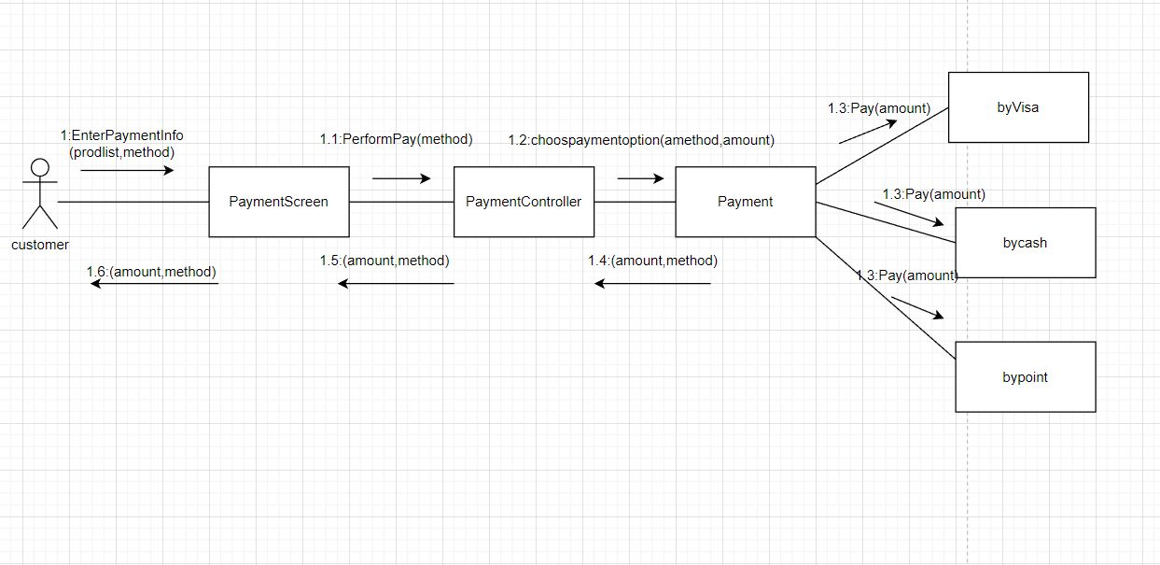

**Communication Diagram for Return Product**

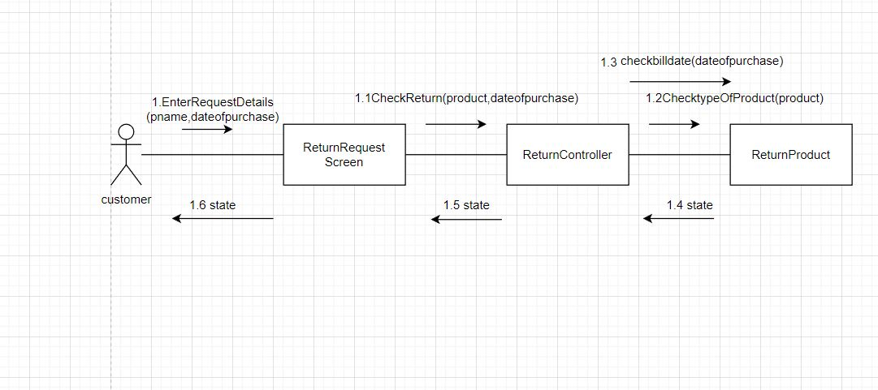

**Sequence Diagram for Payment**

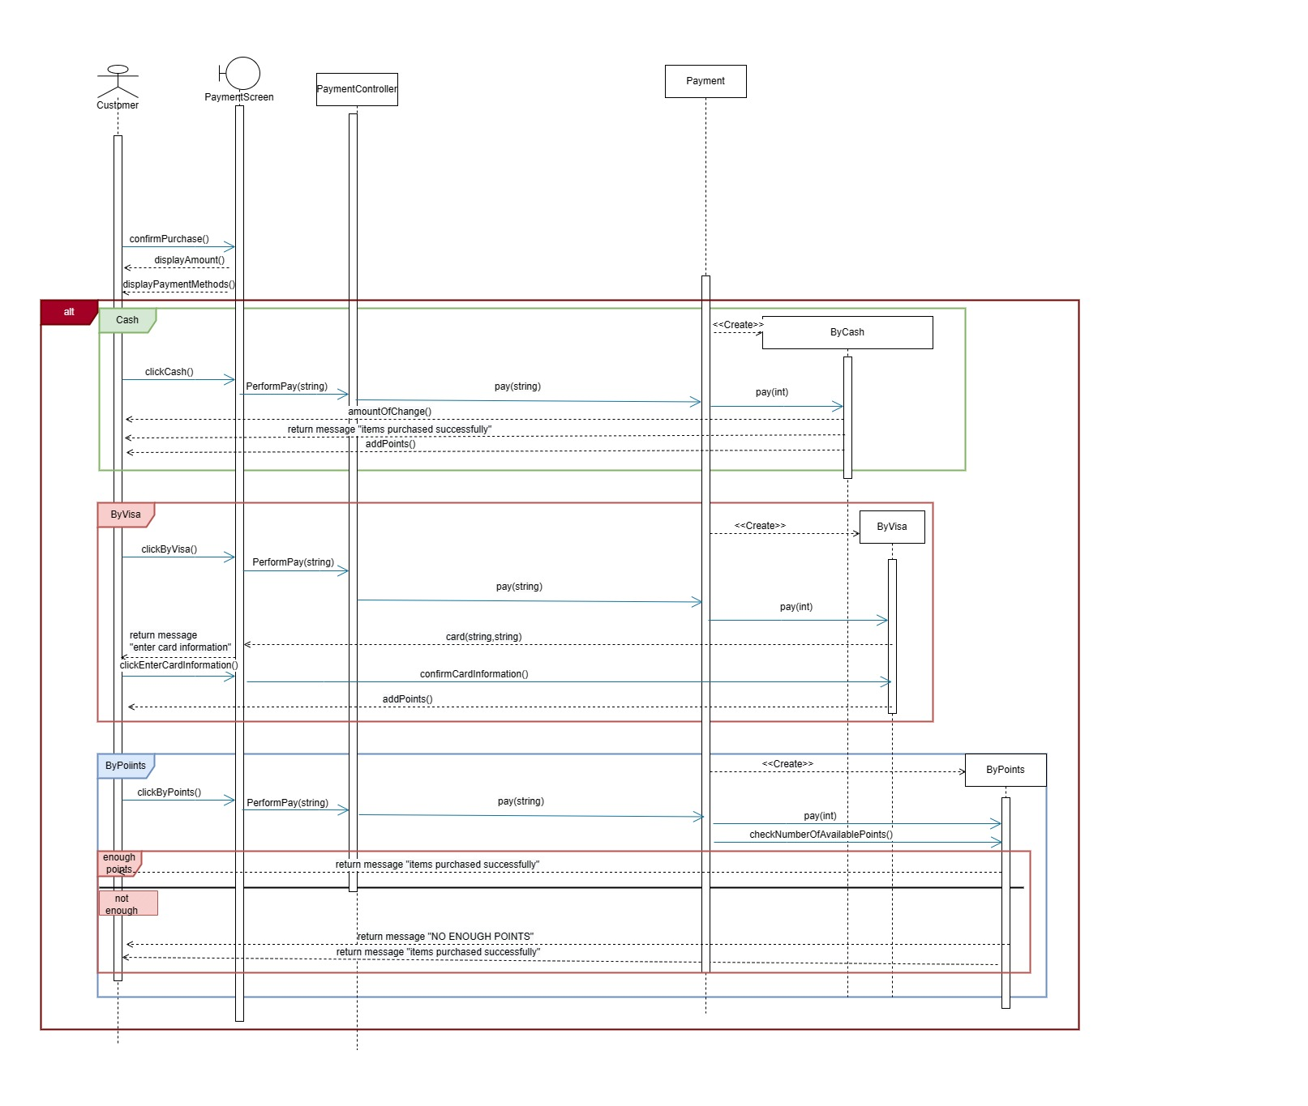

choosepaymentOption(string,int)

choosepaymentOption(string,int)

choosepaymentOption(string,int)

pay(int)

pay(int)

pay(int)

**Partial Class Diagram for Payment**

**Sequence Diagram for Return Product**

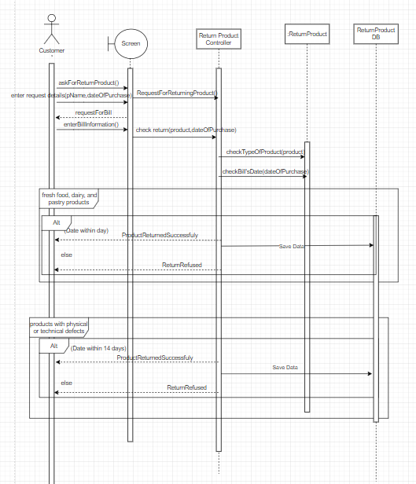

**Partial Class Diagram for Return Product**

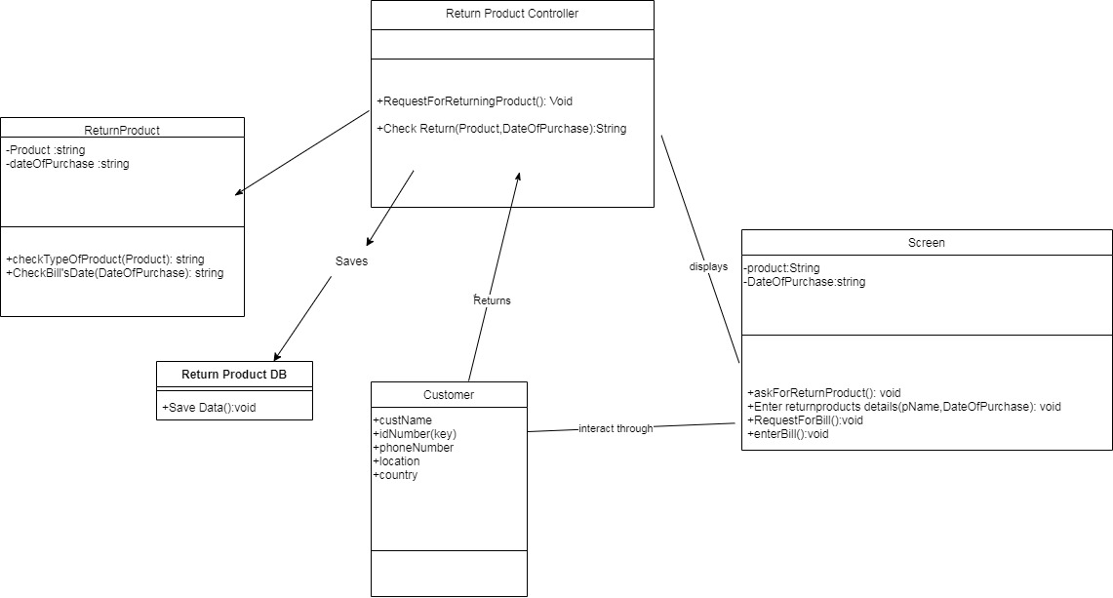

**Detailed Class Diagram**

**Package Diagram**

